**RACE PROPOSITIONS**

**2. KRK GRANFONDO FALKENSTEINER PUNAT -CROATIA**

**26.04.2025.**

**REGISTRATION:**

[https://protime.si/sl_si/dogodek/2-krk-granfondo2025/?regname=Single%20Registration](http://?)

**EVENT WEB PAGE**:

[https://krkgranfondo.com/](http://?)

**ENTRY FEE AND BENEFITS:**

In order to provide all Granfondo participants with a first-class organized cycling event, we limited the number of Krk Granfondo Falkensteiner Punat participants to 300 people.

Applications until February 15, 2025 EUR 45.00

Applications until February 28, 2025 EUR 50.00

Applications until March 31, 2025 EUR 55.00

Applications until April 15, 2025. EUR 60.00

Applications until April 25, 2025 EUR 65.00

*Registration at the event itself is not possible.

**DISCOUNT:**

Granfondo competitors who have booked accommodation with the host of the event - Falkensteiner hotel Punat - are entitled to the following discounts on the registration fee.

30% discount on entry fees for groups of 4 competitors staying at least two nights

50% discount on entry fees for groups of 8 competitors staying at least two nights

**TRAINING CAMP:**

From April 23 to 27, 2025, this event invites cycling fans to enjoy the beautiful surroundings of the island of Krk. Offering an extraordinary combination of scenic routes, expert guidance from Mia Radotić and socializing with fellow cyclists, this five-day experience is a must-see for anyone who loves cycling. Join the excitement and adventure on pedals on the stunning island of Krk! As Mia Radotić herself points out, "What I particularly like about the race itself is the profile of the track, which is really intended for everyone. It is not too demanding, it allows one to participate in the race and primarily enjoy it without the result priority. However, for the most prepared cyclists there are challenging aspects that will make the course interesting and difficult.” Amidst the stunning backdrop of the beautiful Adriatic coast, participants have the opportunity to enjoy the sea, bicycles and the company of other sports enthusiasts. Mia's quote perfectly captures the essence of the event – ​​a celebration of cycling where everyone, regardless of skill level, can find joy in riding. The support of BikeFriendly hotels adds an extra level of comfort and convenience, ensuring that your cycling adventure on the island of Krk is an unforgettable experience.

The prices for individual reservations are as follows:

- Single room: €100.00 per room/day + €1.80 for residence tax

- Dbl superior + balcony: €132.00 per room/day + residence tax

For group (min. number of rooms 10) reservations the prices are as follows:

- Comfort single room / 73.00€ pd + 1.80€ tax pp

- Comfort double room / 96.00€ pd + 1.80€ tax pp

• Welcome drink for cyclists

• Bicycle storage

• 20% on all Spa center treatments,

• 1 day cycling tour with a group

• Afternoon station with pasta

• Daily isotonic drink per cyclist

• Energy bars for participants

**Wednesday, April 23, 2025**

**PROGRAM GF**

15.00 - 18.00 - info desk inside the hotel Falkensteiner Punat

15.00 - 19.00 - cycling training for 3-4 hours, the group with an escort starts in front of the Punat hotel

19.00 - 21.00 – Dinner

**Thursday, April 24, 2025**

**PROGRAM GF**

7.00 - 8.00 - Breakfast

8:30 a.m. - 12:30 p.m. - Cycling training PASSING THE ENTIRE GF PATH, the escorted group starts in front of the Punat hotel*

12.30 - 13.00 - Stretching (30 min) **

13.00 - Lunch

15.00 - 17.00 - Relaxation at the pools

15.00 - 19.00 - info desk inside the hotel Falkensteiner Hotel Punat

18.30 - 21.00 - Dinner

**Friday, April 25, 2025**

**PROGRAM GF**

7.00 - 8.00 - Breakfast

8:30 - 11:00 a.m. - bicycle training, the group with an escort leaves in front of the Falkensteiner Punat hotel/ a light training ride and a tour of the sights of the island of Krk

11.00 - 11.30 - Stretching (30 min) **

12.30 - Lunch

15.00 - 17.00 - Relaxation at the pools

14.00 - 21.00 - pick up of start packages, in the official office of the race inside the hotel Falkensteiner Punat (identity card required)

10.00 - 21.00 - info desk inside Hotel Falkensteiner Punat

18.30 - 21.00 – Dinner

**Saturday, April 26, 2025**

**RACE DAY: KRK GRANFONDO FALKENSTAINER PUNAT**

**PROGRAM**

7.00 - 8.00 - Breakfast

07.00 - 09.00 - picking up the starting packages, at the official race office inside the Falkensteiner Club Funimation Borik hotel

9.00 - opening of the cycling zone for the race

9.30 - ceremonial opening of the race (ceremonial speech by the GM to all competitors, and info from the program manager)

09.45 - official briefing in ENGLISH by the head judge of the race

10.00 - START OF THE RACE (all categories start at the same time)

1:00 p.m. - 2:00 p.m. - picking up bicycles from the secured area of ​​the bicycle race

13.00 - 14.30 - lunch at the hotel Falkensteiner Punat for the race competitors

15.00 - ceremonial announcement of the winner of the Krk GranFondo Falkensteiner Punat race (on the stage of the Falkensteiner Punat hotel)

**Sunday, April 27, 2025**

**PROGRAM**

7.00 - 10.00 - Breakfast

10.00 - Planned departure from Krk

**\*Official race jersey included in the start package for the ones registerd until 1.3.20025.**

**START PACKAGE:**

• Backpack

• Official race jersey

• Water bottle

• Start number

• Timing chip

• Isotonic drink

• Finisher's medal

• Photos from the race

• Office hours

• Festive lunch with awards ceremony

• Energy tiles

• Water

**CATEGORIES:**

**ABSOLUTE CATEGORY:**

Krk GranFondo Falkensteiner Punat

**Men**

Gentlemen: 15-34 years

Gentlemen: 35-49 years

Gentlemen: 50g+

**Ladies**

**Ladies: 15y-70y absolute category**

**(If there is a large number of applications and a large age disparity, we will separate the two categories)**

**PRIZES:**

Male competition

1st Place – 4 nights at Falkensteiner Hotel Punat for 2 people

Women's competition

1st Place – 4 nights at Falkensteiner Hotel Punat for 2 people

**RACE INFO:**

**Date**: Saturday, April 26, 2025.

**Start**: 10:00 am

**Starting point**: In front of the Hotel Falkensteiner Punat

**Finish:** At the entrance to the town of Punat, on the bypass on a short hill

**Distance**: 82 km

**Elevation gain**: 1320m

**GPX TRAILS**:

[https://drive.google.com/file/d/148rVODNtLkXW7NIpfYey5iSa4z4rMzuH/view?usp=sharing](http://?)

**STRAVA**:

[https://www.strava.com/routes/3168595389500629622](http://?)

**RACE PROFILE:**

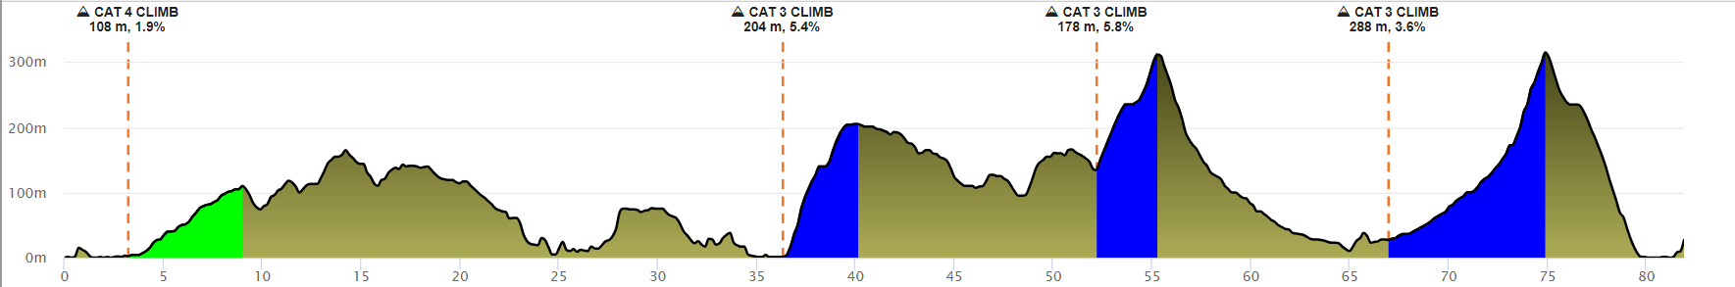

**Categorized climbs:**

**No Starts At Length Height Gain Avg Grade Category**

**1. 3.2 km 5.8 km 108 m 1.9% 4**

**2. 36.4 km 3.8 km 204 m 5.4% 3**

**3. 52.2 km 3.1 km 178 m 5.8% 3**

**4. 67.0 km 7.9 km 288 m 3.6% 3**

**RACE MAP:**

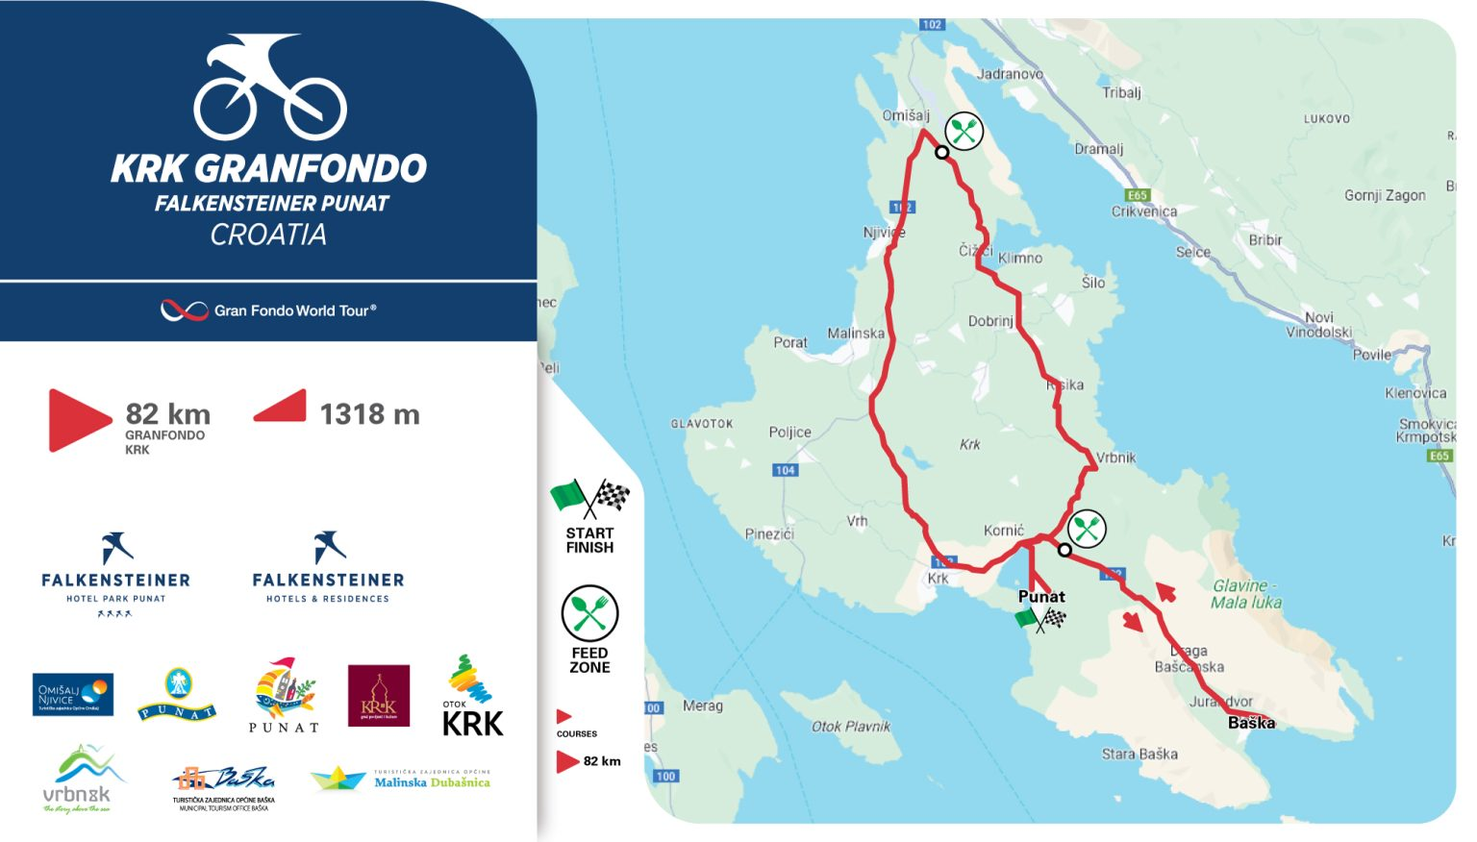

**FEED ZONE:**

• 29 km – after turning off the state road 102 above Omišalj Municipality towards Čižići

• 55 km – Treskavac – at the top of the pass, before the descent towards Baška

**START AND FINISH POINT:**

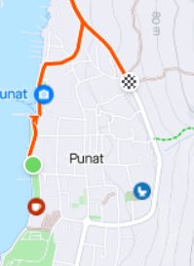

**TIME MEASUREMENT:**

It will be carried out automatically with the use of a computerized system with chips by the

PRO TIME system.

**TIME TABLE:**



**OFFICIAL BIKE SERVICE:**

A professional bicycle repairer will, upon request, service bicycles for all competitors at the Krk Granfondo Falkensteiner Punat event, and guarantees that all bicycles will be in perfect condition at all times. Bicycle service during the event is free, but the used material is charged.

**EMERGENCY MEDICAL AID:**

The participants of the race will be accompanied by emergency vehicles and doctors during the entire route. First aid at the scene of the accident is the sole responsibility of the rescue organization and is free for all participants.

**BROOM VEHICLE:**

Most likely, some of the participants will not be able to successfully complete the given routes If by any chance you happen to be one of them, please wait for the "broom" vehicle directly on the route. Participants, as well as bicycles, will be returned to Punat in different vehicles.

**GENERAL REGULATIONS:**

The ROAD technical regulations of HBS and the ROAD UCI regulations and the general rules of the UCI apply to the event. Drivers adopt these propositions at the start of the race and drive at their own risk. The organizer is not responsible for acts committed by the driver towards third parties. The race is run regardless of weather conditions. The organizer reserves the right to change the conditions of the race without prior notice.

**COMPLAINS:**

According to the regulations, in writing, with a deposit in the amount of 50 euros. For complaints about events during the race - within 15 minutes after the finish. For appeals about the results - within 15 minutes after the results are announced.

**BY THE VERY ACT OF APPLICATION, THE CONTESTANT EXPRESSLY DECLARES THAT:**

• agrees to compete in the race at his own risk and personal responsibility, and that he is familiar with the rules and regulations of the race and the risks that such a competition contains,

• waives the right to ask the Organizer for compensation for any damage, except for that which could be attributed to the Organizer's intention or gross negligence,

• the organizer will not be held responsible for the possible failure to fulfill their expectations or success in the race

• the organizer will not be liable for any direct or indirect, accidental, immaterial or material damage, losses or expenses of the competitor,

• that he is in adequate psychophysical condition suitable for this type of competition,

• the organizer can use and process the entire filmed and photographic material without any compensation and publicly show and use it for the promotional purposes of the race,

• by the very act of application, waives the right to refute this Statement on any basis.

**RULES:**

• In the case that a registered participant wishes to cancel their participation in the race, they will not receive a refund, but they can request delivery of the starting package to their home address

• Race organizers will only provide and be responsible for cyclists riding between the main lead car and the rear SAG car.

• Participants who overtake the main leading cars or lag behind the SAG cars at the back, the organizer will not be responsible for them and will not be considered as insured participants of the race.

• No distractions and distractions on the race route: it is forbidden!!! Cyclists are required to dispose of garbage in designated areas on the race route.

• The organizers reserve the right to change or modify cycling routes according to police instructions or due to weather conditions such as floods, fog, rain, strong winds, etc.

• The organizers have the right to check the bikes before the start of the competition. The organizers have the right to prevent a competitor from participating in the event, as well as to terminate their participation during the event without giving an explanation or reason.

• Cyclists are required to stay on the official race route at all times. Shortening or deviating from the designated route of the bicycle race is prohibited.

• Each participant must attend the pre-race briefing. The briefing will be held on April 27 at 09:45 at the start in front of the Falkensteiner Punat hotel.